**Public Speaking in Ancient Greece and Rome**

Greek rhetoric is the art of persuasive discourse, as practiced and written about by ancient Greek thinkers. In ancient Greek society, the ability to sway an audience through language was valued as essential component of civic engagement. The whole society of Ancient Greece was based on the usage of rhetoric. People spoke in public in order to prove their point of view on some issue. It could be politics, private life or other spheres of activity. Different aspects of social life were touched. As a result, it became a standard part of Western education that continued into the 20th century.

Greek rhetoric is most closely associated with the Greek philosopher Aristotle, whose text "Rhetoric," which was written during the fourth century B.C., lays out a detailed analysis of how language and persuasion are tied together.

**Aristotle’s Three Pillars of Rhetorics**

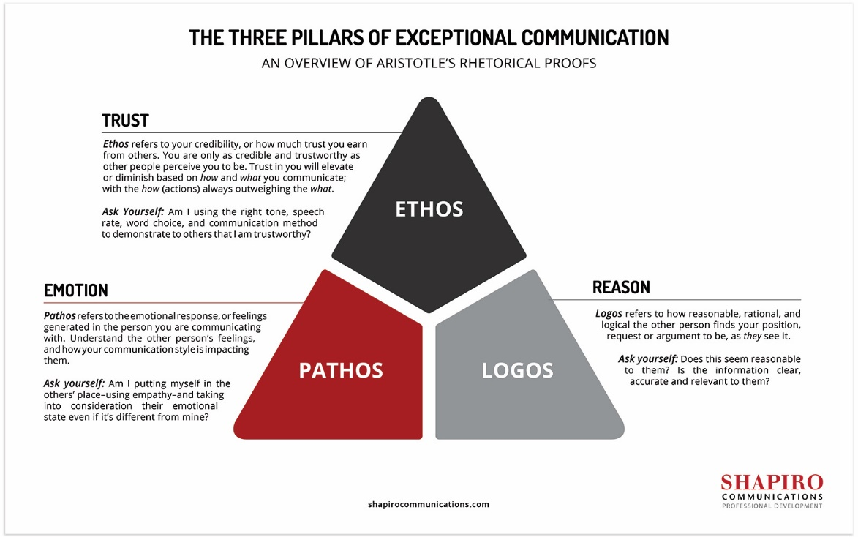

More than 2,300 years ago, Aristotle wrote On Rhetoric, the classic treatise on persuasion. Many people consider it to be the most important work to have influenced public speaking, and it is as relevant today as it was in ancient Greece.

SO HOW DOES ONE PERSUADE OTHERS?

What is the essence of good rhetoric? According to Aristotle, rhetoric rests on three pillars or persuasive appeals:

“The first kind depends on the personal character of the speaker; the second on putting the audience into a certain frame of mind; the third on the proof, or apparent proof, provided by the words of the speech itself.”

These pillars are better known by the names Ethos, Pathos and Logos.

**ETHOS**

Ethos is an appeal based on the credibility of the speaker. A speaker who is not perceived by the audience as being credible will have a difficult time persuading them of anything.

A person’s credibility is based on a number of factors including the following:

Reputation: The speaker’s life experience, achievements, mistakes, etc. can enhance or detract from ethos.

Trustworthiness: The audience wants to be able to rely on what the speaker is saying.

Authority: A person in a position of authority (e.g., the president of a country, the CEO of a multinational) will often have a certain amount of ethos by virtue of the position held.

Expertise: Experts in a given field have ethos when they speak about that field.

Similarity: A speaker can generate ethos with an audience by calling out areas or characteristics that he shares with the audience.

Manner: The way in which a speaker handles herself on stage – her voice, her body language – can affect her ethos.

**PATHOS**

Pathos is an appeal to the audience based on emotion. Emotions are powerful things. William James said,

“The emotions aren’t always immediately subject to reason, but they are always immediately subject to action.”

Speakers can tap into the emotions of an audience in several ways:

Storytelling: Telling a story is one of the most powerful ways to make an emotional connection with an audience. Stories add meaning and stories are memorable.

Call to action: Appealing to one’s sense of purpose or duty can stir up powerful emotions.

Visuals: Showing a powerful image or video can elicit an emotional response from the audience.

Metaphors: Anchoring your new idea to something which the audience already knows and about which they feel strongly can evoke an emotional response.

**LOGOS**

Logos is an appeal based on the logic of the argument. Does it make sense? Is it well structured? Does the evidence support it?

The following are some of the things that a speaker can use to strengthen the logos of his speech:

Data/Facts/Statistics

Test results/Survey results/Research results

Charts and diagrams/Demonstrations

**STRIKING THE RIGHT BALANCE**

People often ask me which of the three persuasive appeals is the most important? I believe that they are all important and that a good persuasive speech contains elements of all three. However, you need the right amount of each.

You always want your ethos to be as high as possible. There is no such thing as too much credibility. When it comes to logos and pathos, however, you will want to adjust the amount of each, depending on the subject and the audience.

For example, an engineer presenting technical finds to an audience of engineers will probably want more logos and less pathos in her presentation. Too much pathos and not enough logos will adversely affect her credibility. But that does not mean that there should be no pathos at all. Engineers are people with emotions who can be inspired or excited by ideas.

So if you have several different speeches to give, you will want your ethos to be as high as possible in each of them. The amount of logos and pathos will vary. But all three should be present.